Saduq Rahman

January 31, 2021

Foundations of Programming, Python

Assignment 3

**Beginning of the CDIventory Python Script**

**Introduction**

In assignment 5 I go thru the process of explaining the steps in creating a list and “for loops” while also asking for users to utilize a menu to either save to a .txt delete entries are just view current inventory. I wanted to expand on this week’s assignment so I incorporated an “while true” and “else” statement within the script, so if the user enter an option that was not valid they would be prompted to make a different selection.

**Drafting the Code**.

I used the program spyder to write and test the code being written, my first step was to create variable called “dicRow1 - 3” which is being used to hold data to be recalled using a “for loop” than created a lstTble to hold all data from the list above. Chapter five really helped solidify the concept of both dictionary and the list concept (Dawson, 2010). So, when writing and formulating the code in the starter kit that was given, the idea of substituting the list table for a dictionary with key pairs was easy to comprehend. The biggest issue I had was creating a loop to delete an entry from the dictionary row using the ‘ID’ as the key. After some trial and error I was able to get the loop to work and created an else statement in the loop that would be triggered if the user entered something not found in the dictionary.

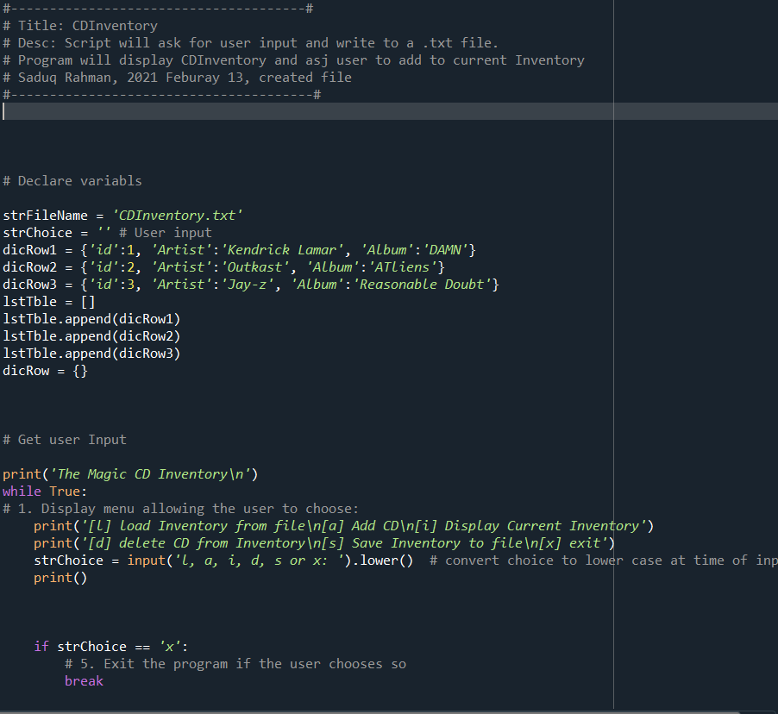

Figure I

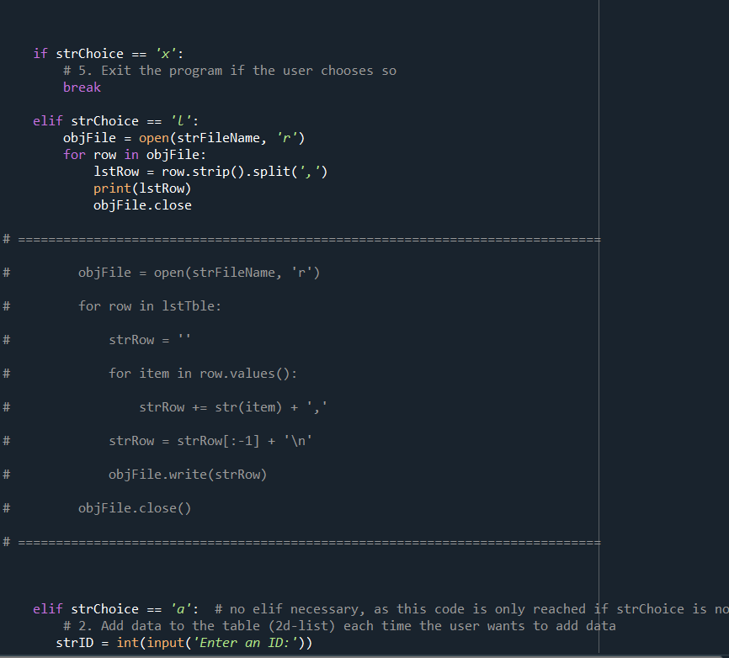

Figure II

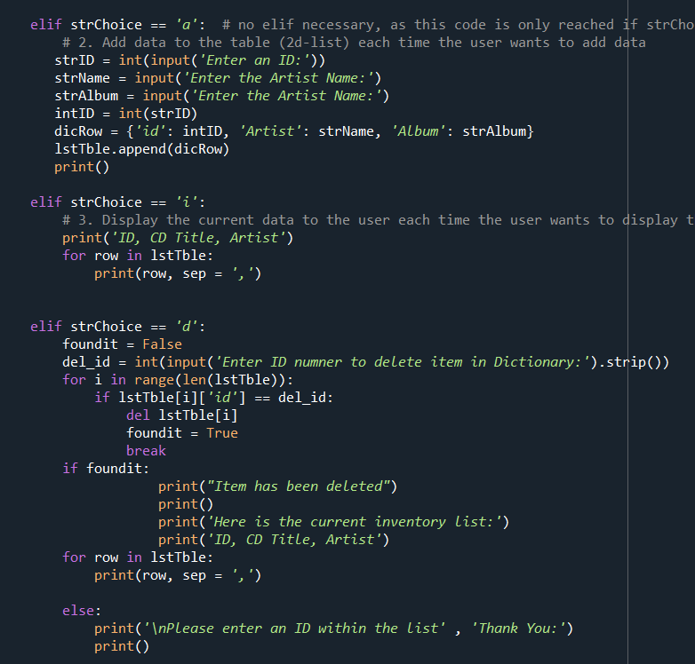

Figure III

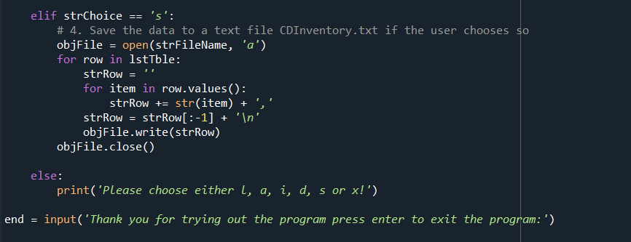

Figure IIII

**Operations:**

The output in the program displays the current inventory for the user within the program, the issue I had was getting it to display in the txt file in 2d print. So, I am hoping after you take look at the code you can help me improve on that aspect.

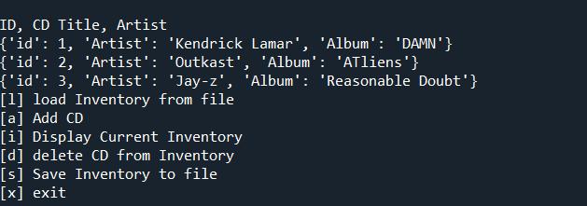

Figure V

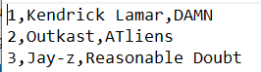

Figure IV

**Summary**

Using the textbook, the Module 05 documentation and videos, and the supplemental websites and video, I was able to successfully create a script that took the users input and wrote it to .txt file. Looking forward to improving on the concepts I have learned so far. I have collaborated with Mitchell Post who I worked with some of the syntax issues I was facing.